# SOLUTION ARCHITECTURE

**Design:**

* Water content in the soil can monitor using moisture sensor.
* Nutrients and PH level in soil can monitor by NKP sensor and PH sensor.
* Plants affected by pests or any diseases can identified by pest detection sensor and cameras.
* Temperature in atmosphere can detected with the help of BMP sensor.
* Alerts the authorized farmer to take the necessary action based on the information.
* Watering time can be automatically allocated based on data from the moisture sensor.
* Farmer can monitor the plants growths continuously through a web App.

# Software and system required:

* + Arduino IDE
  + Embedded C
  + 4GB processor and OS-Windows/Linux/MAC

# Block diagram:



User

Cloud Service

IOT DEVICE

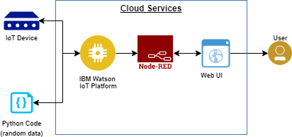

**IOT Device**

solenoid valve

NKP sensor, moisture sensor, BMP sensor, pest detection sensor

ARDUINO***/***

ESP8266

**Cloud Service**



Cloud DB

IOT Devices

Web UI

IBM Watson

Node red